# Why full stack web development ?

*Lesson 1 of 4*

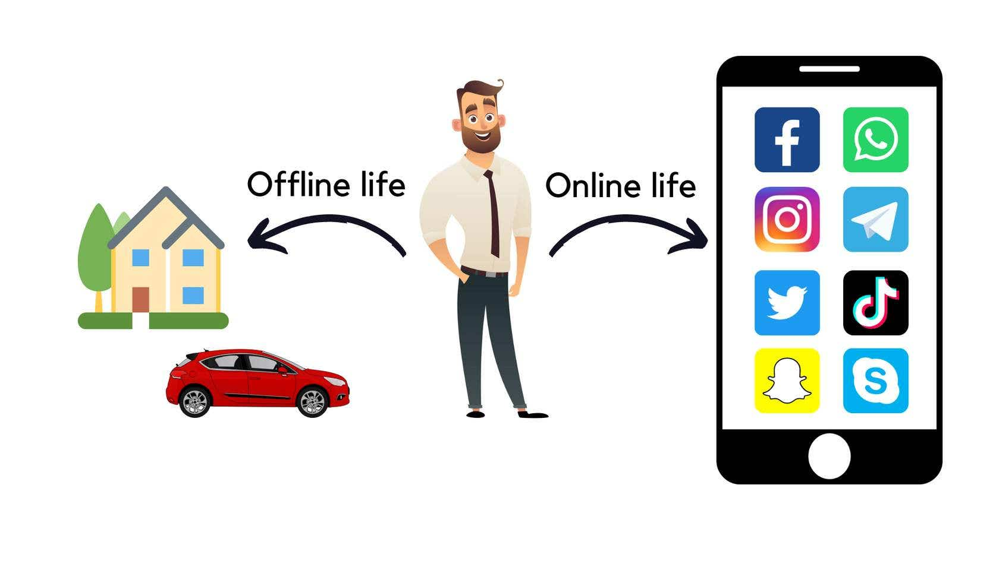

Every human in todays's life have 2 life i.e

1. Offline Life.
2. Online Life.

Precisely, offline life mean house, car, traveling, work, office etc,.

Online life means having different app handles like facebook account, social media exposure like posting photos,video etc.

“If your business is not on internet, then your business will be out of business”.

****Bill Gates****(Co-founder of Microsoft)

“If your business is not on internet, then your business will be out of business”.

****Bill Gates****(Co-founder of Microsoft)

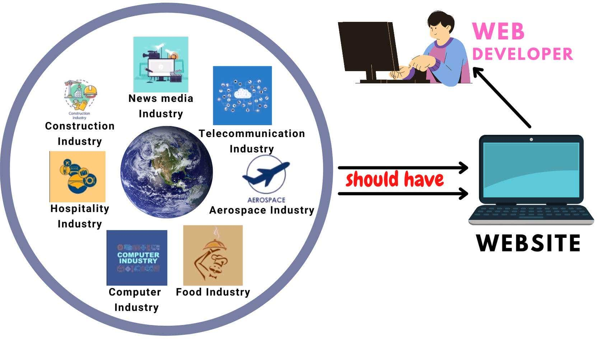

As famous business man said every business should be in internet also we are living in digital world that all the industries across world like Construction industry, Aerospace industry, Media industry, Agricultural industry, Food industry etc. also have a digital presence by having ****"WEBSITE"**** .

The person who creates the website is known as ****"WEB DEVELOPER"****.

Technically, website in software developer terms called as ****"WEB APPLICATION".****

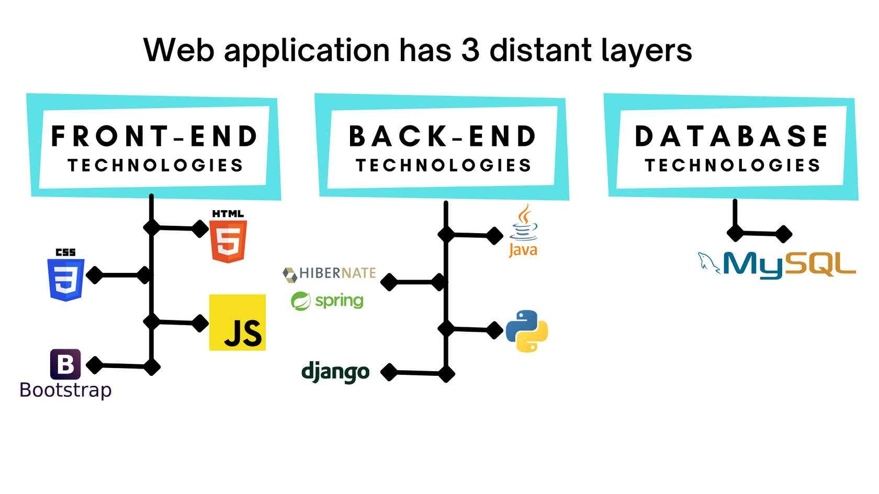

# Introduction to web application.

*Lesson 2 of 4*

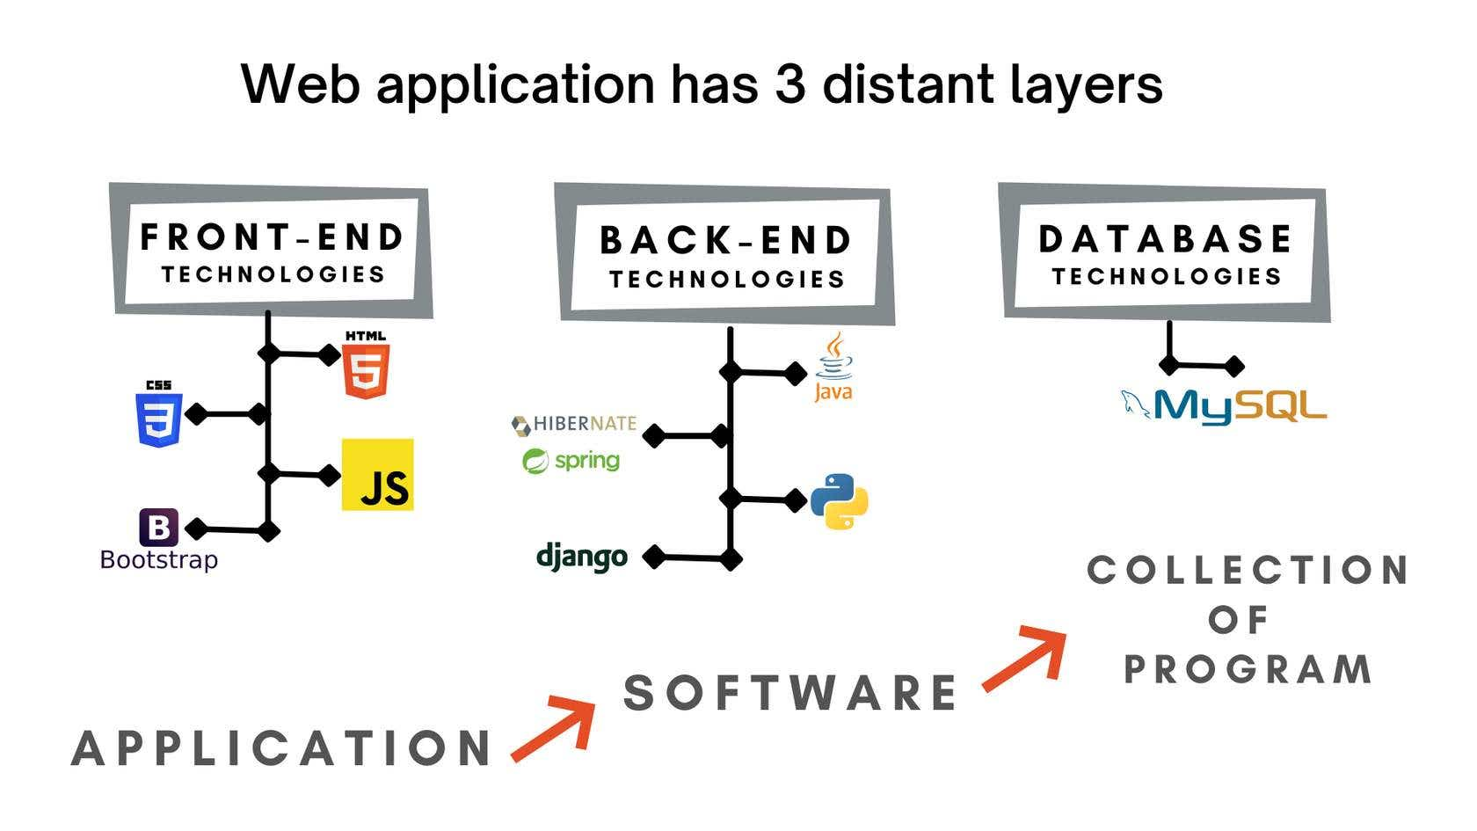

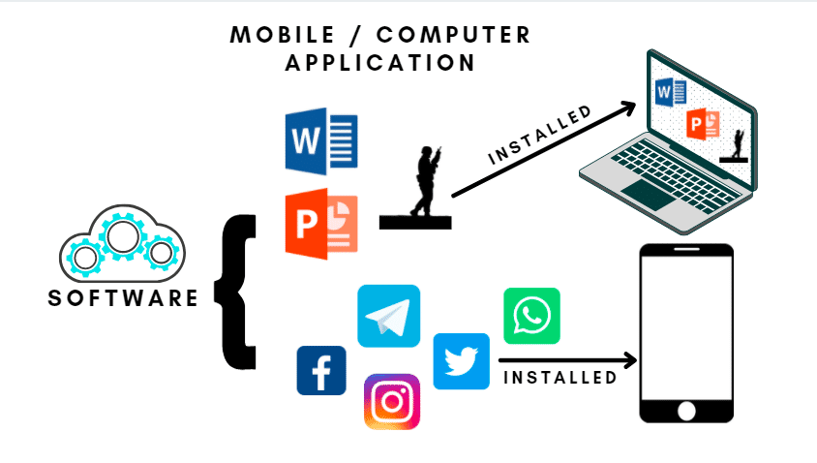

To use certain application or software we have to first install it in our system. Only then we can use it whether it is any game or MS Office or any other software.

**How can we access web application ?**

User can access the application in the server computer no matter where user location is, such application is called as Web application.  Installation, computation, execution takes place in the server computer itself.

Web applications are accessed by the user through a web browser with an active internet connection.

To access the particular web application, we need to send the request to the server via the internet and the server will execute the request and send back the response in form of an application to you via internet.

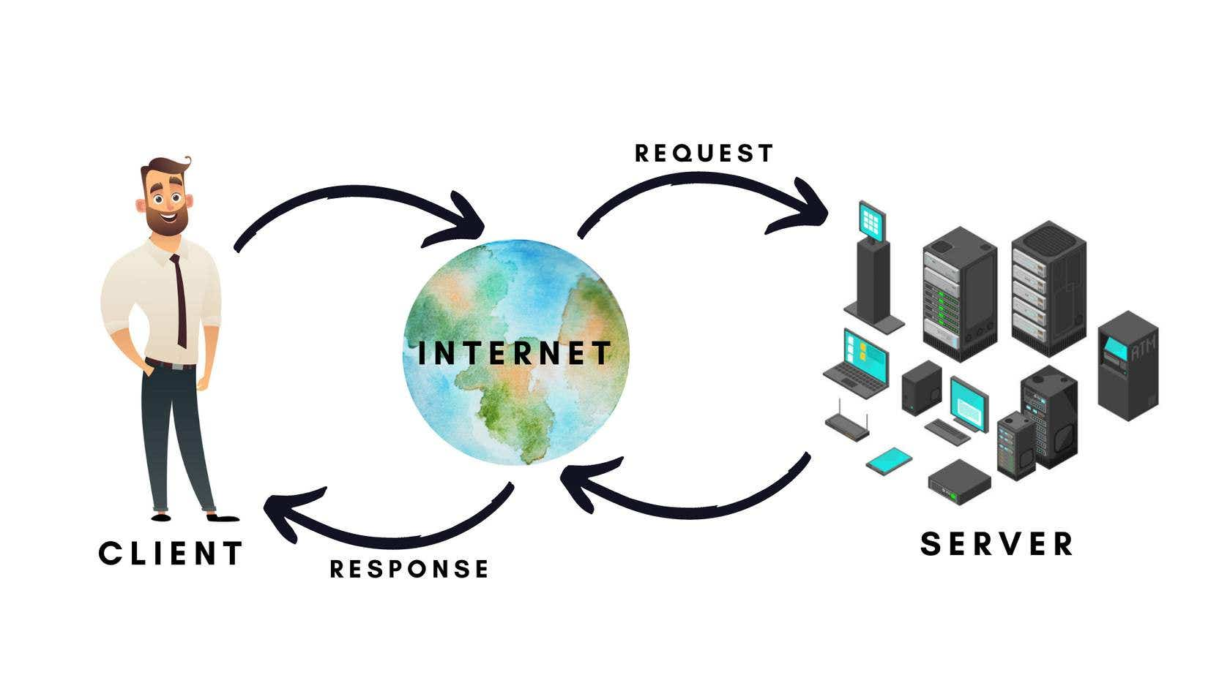

# Layers of web application.

*Lesson 3 of 4*

****LAYERS OF WEB APPLICATION****

## **HTML [ HYPER TEXT MARKUP LANGUAGE ]**

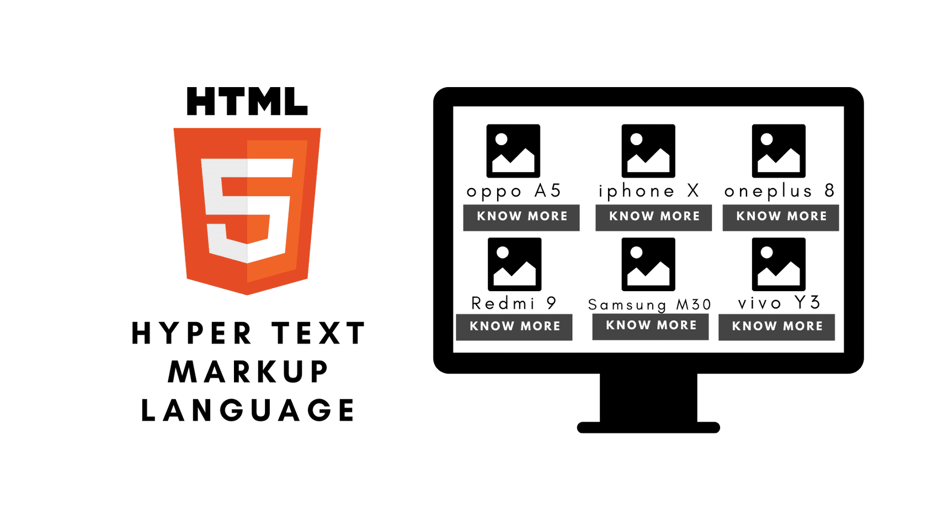

Our expectation is to see all the mobiles with their photo, name and additional information.

To arrange the data in certain way, we have to use a markup language that describes the structure of the web page.

## **CSS [ CASCADING STYLE SHEETS ]**

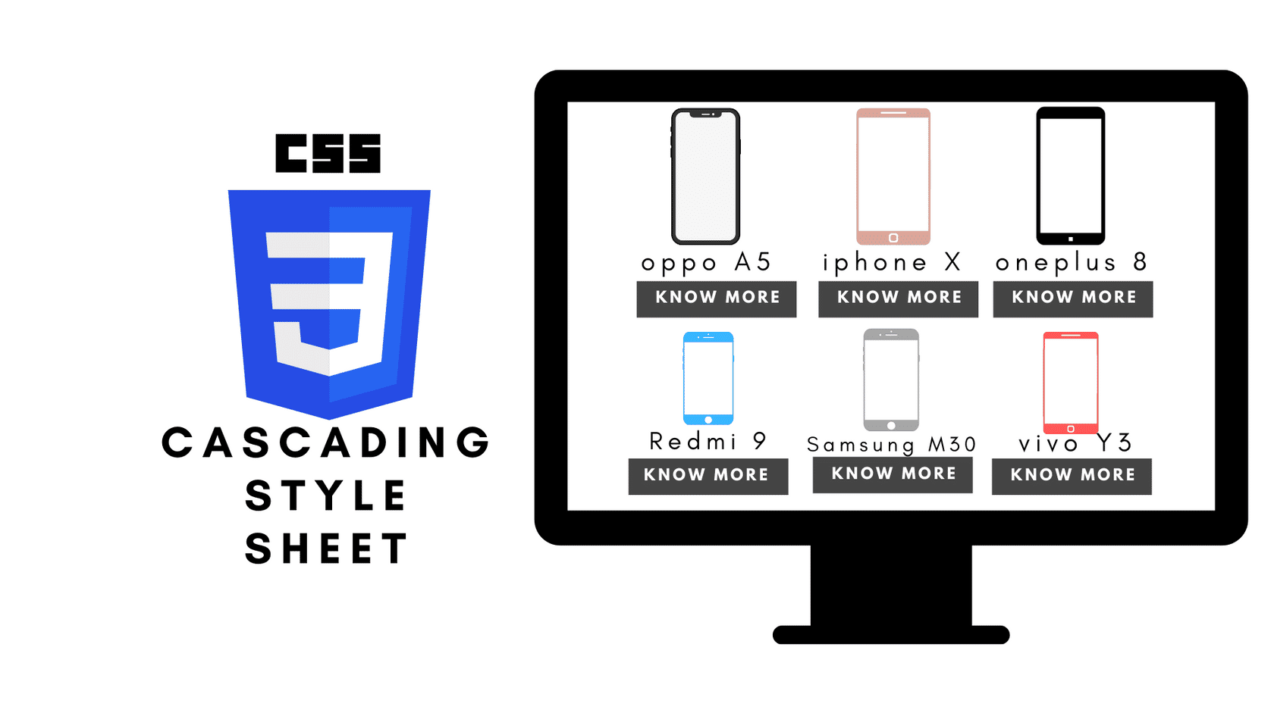

The data has to be displayed in certain format and design, for that we have CSS (Cascading Style Sheets) that describes how HTML elements are to be displayed on screen, paper, or in other media CSS saves a lot of work. It can control the layout of multiple web pages all at once.

## **JAVA SCRIPT**



We see certain websites have some popups that try to interact with us and give some deals/discounts.

For this interactive interface we need a scripting language such as JavaScript. It is a crossplatform, object-oriented scripting language used to make webpages interactive.

For example :- to have dynamic response, having complex animations, clickable buttons, popup menus, etc..

## **BOORSTRAP**

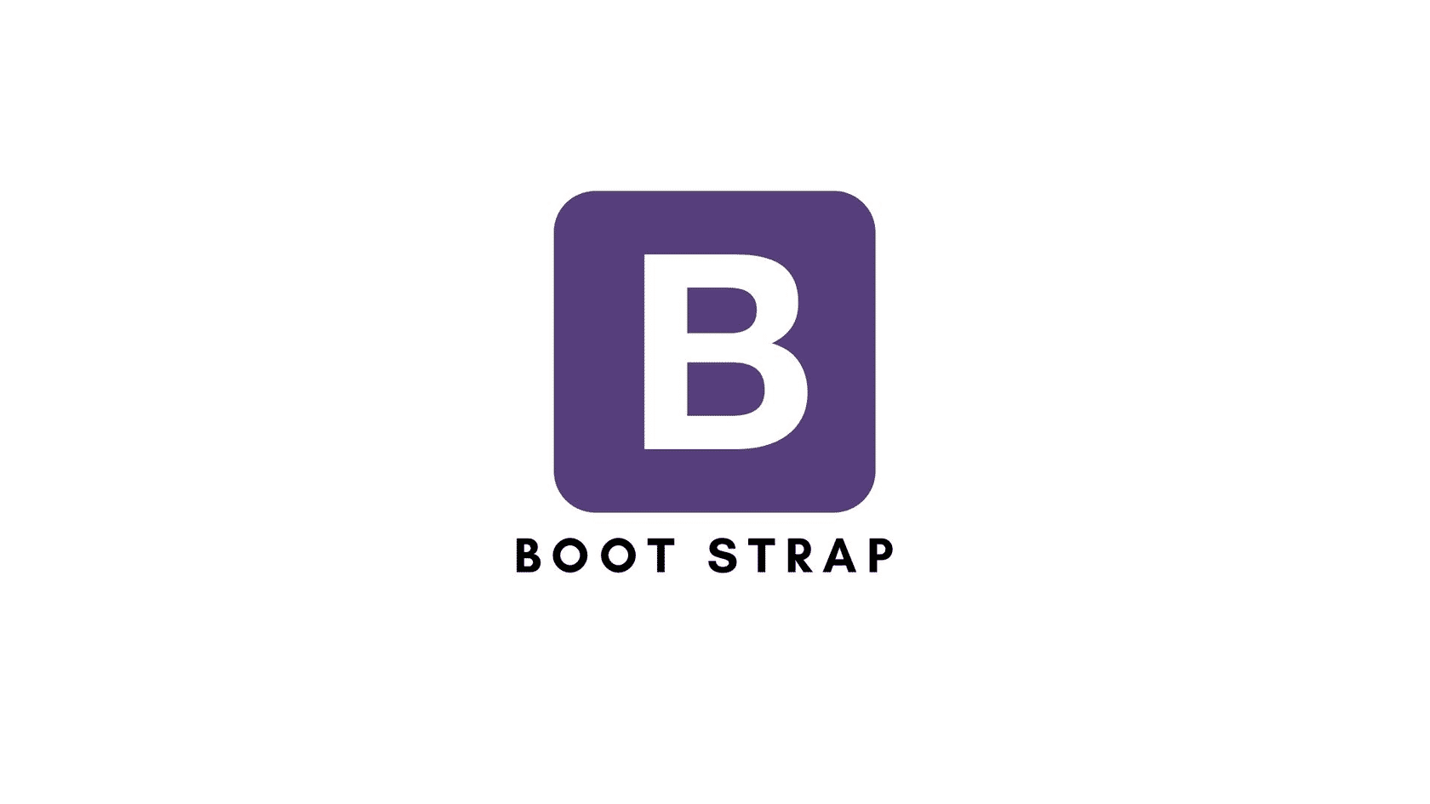

Frame works is a large deposit of code which can be used for common problems, common scenario.

We certainly need a framework that will combine all the above operations.

Bootstrap is the most popular HTML, CSS, and JavaScript framework for developing responsive, mobile-first websites.

## **DATA BASE**

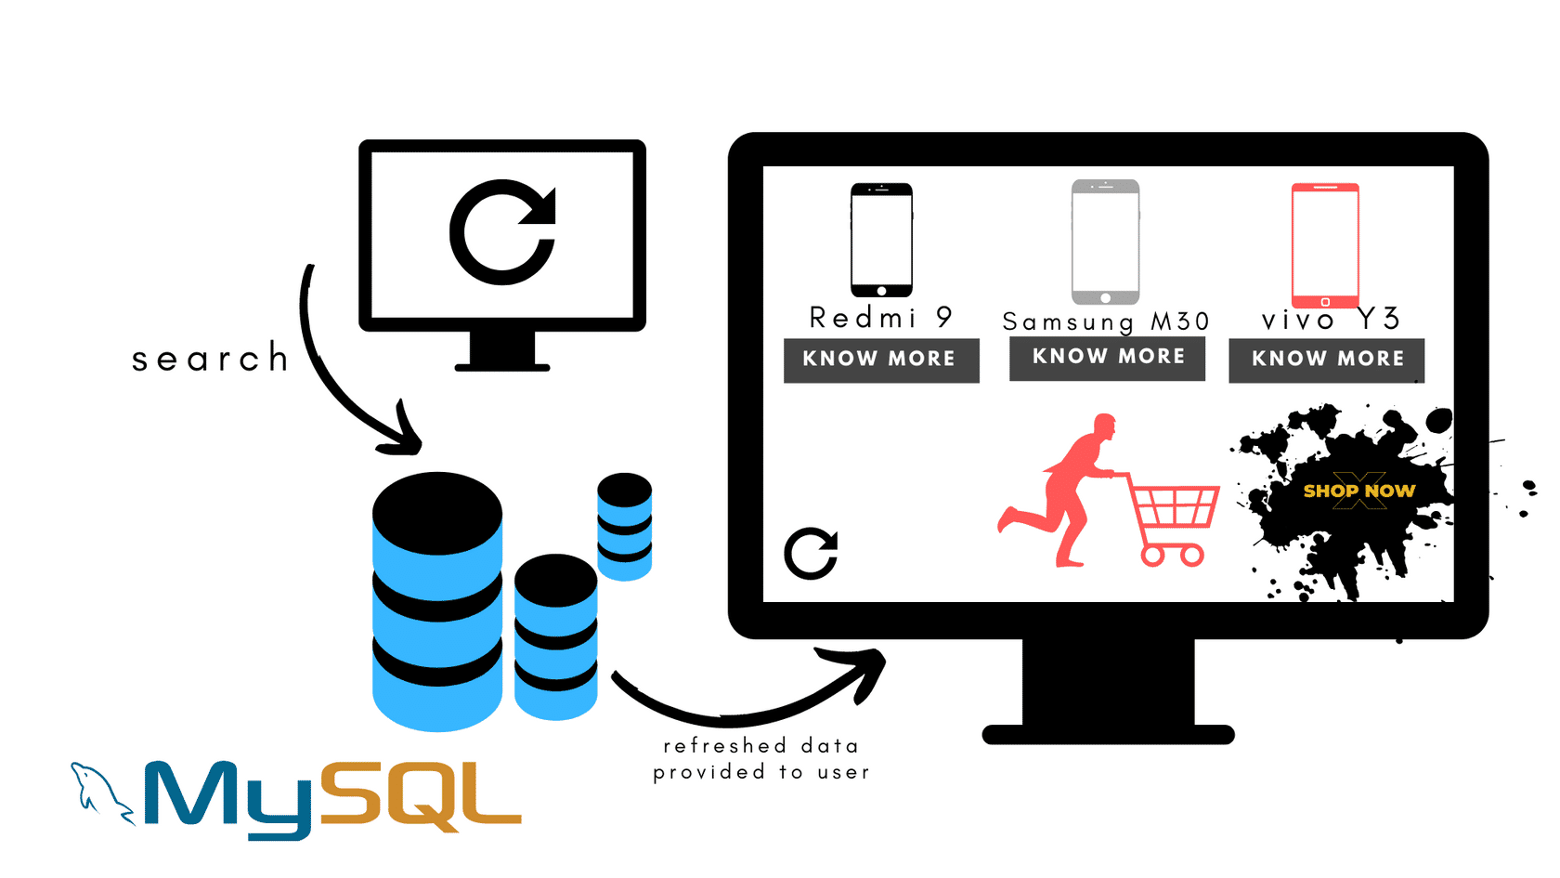

Once we refresh the web page it will provide us new information. But,Data will not be stored nor computed nor executed in front-end.

To stored the information we need data base. There are many tools to manage the data.

FOR EXAMPLE :-

MySQL

PostgreSQL

Oracle

mongoDB.

Here we shall be making use of MySQL. It is a database system used for developing web-based software applications.

## **BACK END TECHNOLOGIES**

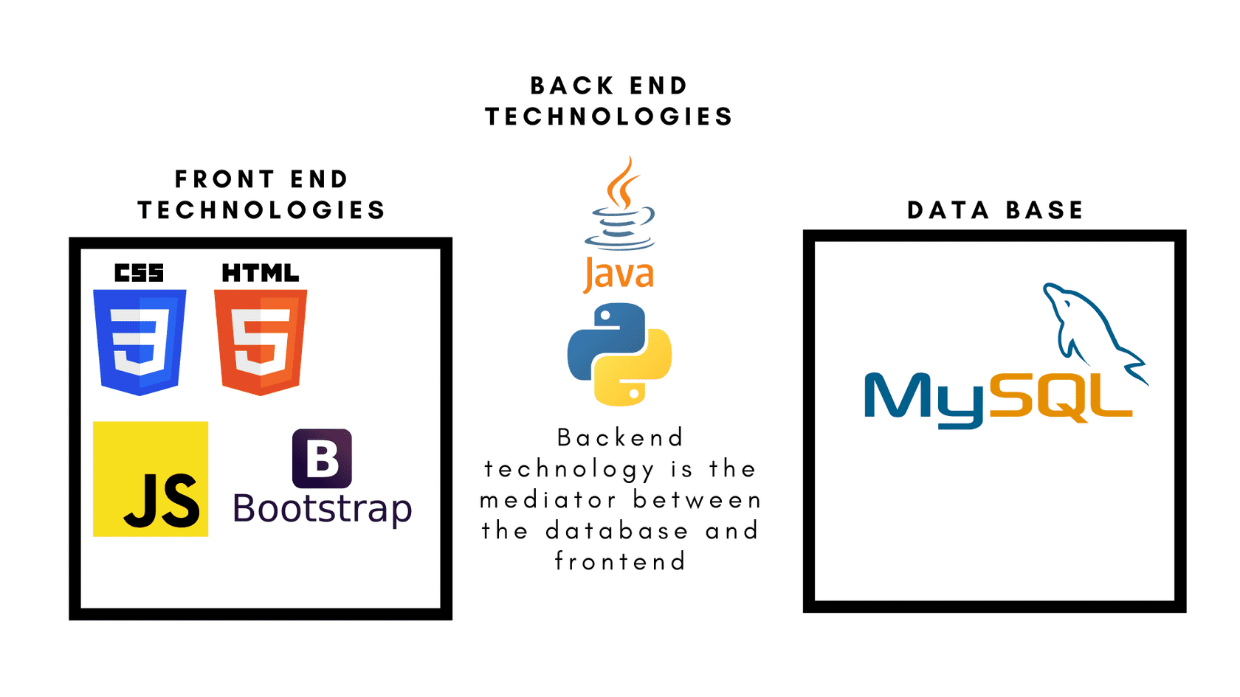

There is a mediator between the data base and the front-end, because front-end cannot understand the language of database and front-end cannot interact with database and fetch the details as per requirement. It is this layer that manages both front-end and database.

There are many languages including frameworks

Java - Springs & Hibernate

JavaScript- Express JS & Node JS

Python - Django & Flask

C#/C-sharp- .NET Core & .NET MVC

THIS ARE THE LAYERS OF WEB APPLICATION.

AND FULL STACK WEB DEVELOPER MUST KNOW ALL 3 LAYERS i.e.

1. FRONT-END TECHNOLOGIES.

2. DATABASE.

3.BACK-END TECHNOLOGIES.

# 

# HTML

*Lesson 4 of 4*

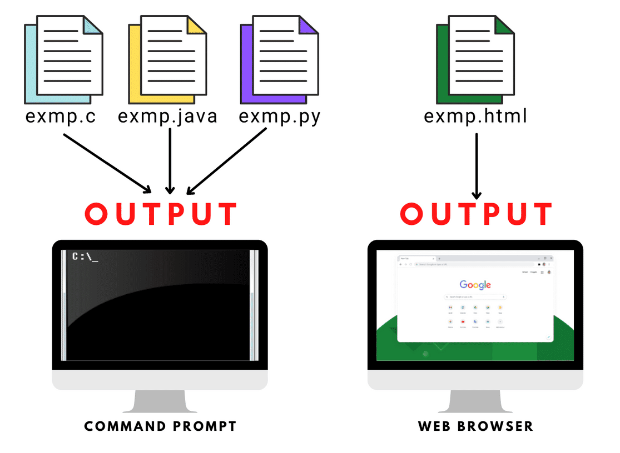

****HTML****

HTML is nothing but "****Hyper Text Markup Language"***.***

* The syntax of markup languages are composed of tags.
* Tags allow you to present data the way user wants to present.
* Different tags have different name.
* The name of the tag is enclosed with triangular brackets < >.
* It is very much black and white presentation.
* There is no styling tags in HTML.
* Styling the HTML Tags is done by CSS.

